# **Proposed level of Achievement:** Apollo 11

# Motivation

As busy students with many tasks and activities throughout the semester, it is difficult and boring to keep track of the numerous assignments and deadlines that we have. It is also hard to stay focused and meet these deadlines as we get easily distracted by our phones while studying.

If only there was an all inclusive application that could help us remember important dates and at the same time, help us to focus when we need to, while helping us to relax and enjoy during our breaks.

# Aim

To have adorable interactive virtual pets that will remind you of your deadlines and help you to stay focused while studying.

# Features of application

## 

## Login Page

When users first use the application, they will be directed to the registration page where they are asked to type in their name and choose a starter pet. The other two pets will appear in the pet shop in future. If the user tries to click confirm without keying in his name or choosing a pet, a text box would appear and prompt them to do it. After registration, the user’s information will be saved on the phone and thus they will be directly sent to the home page the next time they use the application.

## Home Page

## Buttons to access the various features of the application. The top left hand corner of the home page would display the user’s name, the middle would show today’s date while the top right would display the number of coins the user has.

## Coin system

We have made a coin system that would save the amount of coins on the user’s phone. This would ensure that when the user visits other pages in the application or closes the application, the number of coins would not be lost. The amount of coin the user has would be shown on almost every page of the application and users can earn coins through various means which we will elaborate on in this README.

## Pets

This is the pet page of the application. Here you can see all the pets that you own. Clicking on the pets would bring you to the inventory page where you can equip and unequip the items that are bought from the shop. On the top right hand corner is the button to bring the user back to the home page, at the bottom left hand corner is the button to enter the mini game, and the button right hand corner is the shop.

## 

Game

In the spirit of productivity, we programmed a simple and not addictive game that users can play to destress and earn coins as well! Normal tic tac toe rules apply here and every victory will result in a coin gained while every defeat would lose you a coin. But fret not, our fur-get me not bot isn’t the brightest bot around. (As of now at least)

## 

## 

## 

## Shop page

The shop contains a total of 6 purchasable items, 4 items and 2 pets. The 4 items are a party hat, a wand, sunglasses and a halo and they cost 10, 20, 30 and 40 coins respectively while purchasing a pet would cost 50 coins. If the user does not have enough coins but tries to purchase an item, a text box would appear. Only when items or pets have been purchased, they would show up in the pet’s page and after they have been purchased, the item’s icon in the shop will become faded and unable to be clicked.

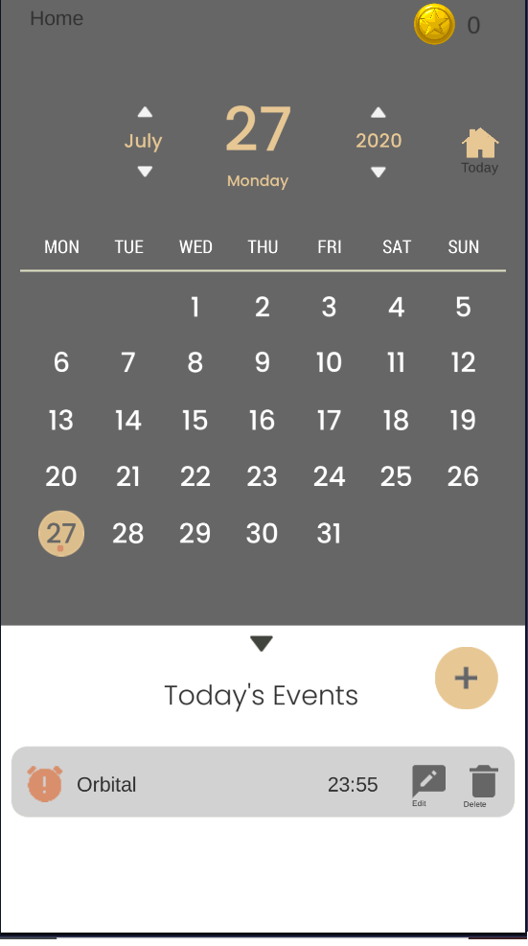

## 

## Calendar

The next main feature of our app is the calendar function. We have successfully implemented an auto generating calendar (thus being infinite) which allows users to select days and add events using the add event button at the bottom. This would prompt an input game object to appear as shown in the next image

## 

## Add Event

## Here is the display of the add event button. As of now, events are only stored by day. By milestone 3, we aim to be able to set events to a more specific time, and also implement push notifications to allow the application to notify the user when these events occur. By noting down events such as deadlines and exams in our application, users would receive 5 coins per event.

## 

## 

## 

## Study Mode

This is also one of the main features of our application. When the user clicks study mode from the home page, they will come to this page and the timer will automatically start. To end study mode, users must click the button End or simply just close or minimize the application. This achieves the purpose as study mode aims to prevent the user from being distracted by his phone while studying. When the end button is pressed, the text on the screen changes and depending on the amount of time spent in study mode, different text appears. We have 3 different texts for when the user hits 15mins, 1 hour and 3 hours of studying. The user’s name is also used in this text to make it feel more personalized. Coins are also awarded based on the amount of time in study mode, every 15mins would result in a coin gained.

Battery saving

As study mode needs to be left on while the user studies, it is important for the phone to remain on, thus we have implemented a script to prevent the screen from switching off automatically. As this can be draining for the device, we have also made some battery friendly changes by introducing a frame rate cap of 10 fps, down from the normal 60 fps.

Music/Settings

What’s a mobile phone game without some background music? We have used a royalty free mp3 ([Link](https://www.bensound.com/royalty-free-music/track/cute)) that loads on the home page and continues playing even when the user visits other pages. This is done by using the DontDestroyOnLoad function in unity. Concerned that the sound might be too loud when the application starts? Worry no more, we have also implemented a settings page where the user can adjust the volume of the background music. By making use of PlayerPrefs, the user’s preferred volume is saved and the application will always start with that volume of music. Users can also change their names in this settings page just in case they spell something wrongly.

Developer

The developer page has some functions that helped us test and debug many of the features in the application. Here, you can enter a developer-study mode where you can manually type the number of hours in, gain 999 coins, reset all user data and set all values to 0.

Achievements

The final feature of our application would be the achievements page. Here, users have a total of 15 achievements that they can acquire. The achievements range from obtaining pets, to collecting coins, to buying items, to the number of hours you have studied, and even to the number of calendar events you’ve completed. Whenever the user achieves an achievement, a text box would appear on whichever page the user is at and inform the user which achievement he has completed. These achievements can be viewed in the achievements page where they are all displayed as trophies of bronze, silver and gold, each representing a different difficulty. Users can press the trophy to view the achievement and can press anywhere on the screen to remove the popup.

